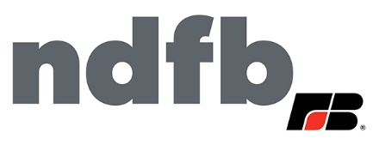

4-H Camp Scholarship

NDFB counties will be sponsoring kids to attend 4-H Camp in North Dakota this summer!
Please fill out the scholarship application and email to Joey Bailey at joey@ndfb.org to see if there are scholarships available in your county.
You do not need to be a 4-H member or NDFB member to apply or attend camp.

Name: _______________________________
Address:____________________ City: ____________ State:____
Zip Code:_______ County:______________________
Have you ever attended 4-H Camp?___________________________
Is anyone in your family a NDFB member? ______________________
Write a short paragraph about why you want to attend 4-H Camp?

Please submit complete application to Joey Bailey at joey@ndfb.org.

