Nominee Assessment
User Guide
&
FORM

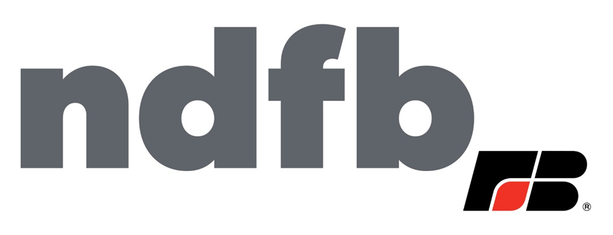

North Dakota Farm Bureau is an independent, statewide, non-governmental, voluntary organization dedicated to improving opportunities and prosperity for all North Dakotans by advocating for our state’s largest, renewable, economic sector: agriculture.
Our vision is to create lasting economic opportunity and the framework for an unsurpassed quality of life for all North Dakotans. We will do this by being the most influential champions for practices, ideas, policies, issues and initiatives that benefit our state’s economic backbone: agriculture. Our intent is to help ensure unencumbered support for farmers, ranchers, entrepreneurs and the self-reliant people who have built our state, and those who continue to build upon that legacy.
Given the vision of the North Dakota Farm Bureau, the NDFB Nominee Assessment Worksheet was developed by the NDFB County Leader Advisory Committee to help establish a system by which candidates seeking the position of district representative who serve on the NDFB board of directors will be evaluated and introduced to the membership. This process is meant to better inform voting choices. The process strives to identify and recruit candidates who are qualified for state board positions. The evaluation helps recognize areas of strengths/weaknesses potential candidates bring to the table.
County Boards of Directors are responsible for completing the Nominee Assessment Worksheet. Signed worksheets must be forwarded to Jeffrey Missling at the NDFB Fargo office 90 days before the State Annual Meeting.
- Criteria are based on the North Dakota Farm Bureau bylaws and other key attributes. The four *starred criteria must be met.

- The numbered criteria indicate past experience/service within NDFB and/or other organizations and skills that have been found to be helpful when serving on a board of directors.

- Numbered criteria help the Succession Planning Committee to better know the candidates and to be able to offer individualized leadership training in areas where the candidate has less skill.
SEND COMPLETED FORM TO: jeffm@ndfb.org

Nominee Assessment Worksheet
*Criteria governed by NDFB bylaws
Criteria | Yes | No | Comments
*Voting member of NDFB |  | Not eligible
*Member of a county Farm Bureau from within the district the individual represents |  | Not eligible
*Family member serving on NDFB BOD | Not eligible
*Employed by NDFB /Nodak Insurance Company | Not eligible
- Presently serves on county BOD |  |  | County:
- Has in the past served on NDFB BOD/ County FB Board |  |  | List:
- Assisted in past NDFB policy development |  |  | Policy(s):
- Attended past annual NDFB conventions/meetings |  |  | When:
- Has served/is serving on non-Ag organization BOD |  |  | Name:
- Presently serve on another Ag organizations BOD |  |  | Name:
- Basic working knowledge of Roberts Rule of Order
- Has working knowledge of NDFB mission, beliefs, purpose
- Working knowledge of responsibilities of BOD
- Working knowledge of financial reports
- Speaking/ presentation skills |  |  | Example:
- Working knowledge of social media, email, teleconferencing, document sharing, document storage access programs. |  |  | List:
- Other skills |  |  | List:

I ____________________________ (nominee) verify the information provided is truthful and accurate. I understand misrepresentation of information is grounds for removal from election process.
Nominee Signature_______________________________________Date_____________________________

